2620 Colonial Dr. STE A  Helena MT 59601  (406) 449-4TAX (829)  (406) 968-4608 – Fax |   Silverman Law Office, PLLC  www.mttaxlaw.com | 504 West Main St.  Bozeman, MT 59715  (406) 582-8822  (406) 968-4608 – Fax

Silverman Law Office - Intake to Onboarding Procedures

This Procedure Book is for Silverman Law Office Team use only

Table of Contents

Contents
Purpose 3
Silverman Law Office Practice Areas 4
Receptionist Script and Call Directing 5
Appointment Setting Script - Silverman Law Offices 8
General Consultation Script (RJ 19-Steps) 10
Initial Retainer Fees 14
Workflows 15
Conflict Checks 16
Payment Procedure 19
Create a Lead 21
Introduction Email – Becki 25
Legal Team Introduction Email 26
No-Show & Rescheduling Protocol 28
Appointment Reminder Phone Calls 29
Consult Complete Email Format 30
Engagement Agreement Follow-Up Procedure 31
Convert a Lead to a Matter 32
Onboarding Outline 33
Qualifying Call /Return Client Outline 36
Onboarding Script 37
Qualifying Call and Returning Client Script 40

Purpose

The purpose of the Intake and Onboarding workflow is to create an efficient and effective process that initiates at first contact. Emphasizing the “flow” throughout this process is focusing on key components that are highlighted in this procedure; these are timely responses and little lag time between contacts, the right teammates completing the right tasks, and maximizing conversions throughout the PCLC process.

Intake Flow:
- Intake Coordinator (Lead/Book)
  - Initial 11-step Intake/Call
  - Creates a Lead in Smokeball
  - Conducts initial conflict check
  - Calendars the meeting with the client coordinator
  - Collects payment for the meeting with the client coordinator
  - Sends “thank you” email and introduces the client coordinator
- Client Coordinator (Show)
  - Sends reminder emails to upcoming meetings with the client coordinator
  - Conducts 19-step meeting
  - Collects retainer
  - Picks attorney
  - Sends introduction email about the Legal Assistant (Free service noted)
  - Send consult complete email to Legal assistant once the retainer has been collected
- Legal Assistant (Pending Hire)
  - Drafts and sends EA to the client; once signed, the legal assistant finishes the following steps
  - Aides in setting up client portal (video instructions)
  - Sends EA, that was signed by the client, for signature by the Attorney
  - Legal Assistant schedules an onboarding session for Attorney
  - Sends consult complete email to Attorney after the onboarding session is scheduled
  - Sends follow-up email introducing the client’s legal team (Attorney, and Paralegal if known), and any documents that are to go to the client prior to onboarding
  - Google Review
- Legal Team (Hired)
  - Attorney conducts onboarding
  - Amend EA, if necessary (Back to Becki)
  - Provides client with firm swag (TBD)
  - Attorney notifies Paralegal (and/or co-counsel if they weren’t on the onboarding) to schedule kickoff meeting

Silverman Law Office Practice Areas

Firm is licensed in Montana, Idaho, North Dakota, Washington, Wyoming, Texas, Colorado, and New Mexico. However, we only take litigation cases in Montana.

The firm has offices in Helena Montana and Bozeman Montana.

- Estate Planning
- Probate and probate litigation
- Guardianship and Conservatorship
  - Protected party must be age 18 or older
- Business Law
- Gambling and Liquor Law
  - Generally limited to business matters
- Real Estate Transactions
- Tax law
  - We do not file taxes
  - We do not do bankruptcy law
- Professional Licensing Defense
- Regulatory Compliance Law
- Oil and Natural Gas
- Labor Employment Law
  - We generally represent the employer, not the employee (except for licensing matters)
  - We can review employment contracts for employees
  - We can also represent independent contractors and sole proprietors
- Cannabis Law
  - Generally limited to business matters
- Business Litigation
  - We generally represent businesses, not customers
- Landlord/Tenant disputes
  - We represent landlords, not tenants
- Real Estate Litigation
- Prenuptial Agreements

Receptionist Script and Call Directing

The purpose of this script is to A) ensure we are polite and professional, B) collecting appropriate information before transferring calls, and C) Directing the caller to the right person for optimum client satisfaction.

- Be pleasant. Smile before you answer the phone, it will change your tone of voice. Try to answer the phone on the second ring. No eating or chewing gum while answering.

- Silverman Law Office, this is _______________, how may I help you?

- Okay, may I get your name please? (If they have not already provided).

WANTING LEGAL ASSISTANCE

- Of course, let me get some quick information. Are you a current or prior client?
  - (YES)
    - So I can let the attorney know, can you briefly share with me what you are calling for?
    - Call the attorney and advise of the caller and reason for call.

  - (NO) – Continue to Step 2

- May I ask if you were referred to us or how you came across our firm?

  - (Not referred by someone – see example section) Okay, let me get you in contact with our intake department and they will gather more information from you to get you to the right person.
    - Transfer to Sabastian

  - (Referred by someone AND to someone specific – see example section) continue to Step 3

- Are you representing a business, and if so, can I get the name of the business please?

- Is (read back the number on caller ID) the best number to reach you at if we get disconnected?

- Thank you. Last question, So, I can let the attorney know, can you briefly share with me what you are calling for?

  - Thank you. May I put you on hold while I see if he/she is available?
    - Contact attorney, provide info and see if they want to take the call.
    - Transfer to the attorney or transfer to VM.
    - Attorney conducts a 15-minute qualifying call, or redirects the caller to appropriate attorney or to intake.

ASKING FOR ANY OTHER STAFF

- Of course, let me ask a couple questions.

- May I get your name and name of your/the business?

- So, I can let them know, can you briefly share with me what you are calling for?

- Thank you, may I put you on a brief hold while I see if they’re available? Great, please hold.

- Inform the client if you are transferring them, or if the person is unavailable then notify the caller that you can transfer them to voicemail.
  - Notify them when you are making the transfer.

Examples

Referred by someone
“Local Financial Advisor referred me Grant”
“My neighbor referred me to Kasey”
“I saw Jill’s presentation on…”
“I met Tony at ____ event”
“ABC Law Firm told me to speak with Joel”

Not referred by someone
“Legal Zoom referred me”
“I saw an article in the Independent Record”
“I saw reviews about Joel”
“I heard Silverman Law was a great firm”
“Found you on Google”
“I was referred to your firm, but to no one specific”

CALL INTAKE FLOW CHART

Appointment Setting Script - Silverman Law Offices

Hi my name is Sebastian, and I am one of the legal assistants with Silverman Law Offices. With whom do I have the pleasure?

Hi (NAME), is this the first time you're calling our firm or are you an existing client?

Perfect, tell me how can we help you today?

(Transfer to Jesse: Corporate Transparency Act/Fincen Report/BOIR Beneficial Ownership Information Report-1 Hour Tax Situation-14 days of deadline-Quit Claim Deeds)

We can totally help you with this.

May I have your full legal name? (check spelling)
The number you're calling from (check number), is that your cellphone number?
May I have your email address? (check spelling)
May I have your mailing address?
Conflict check:

Out of curiosity, who referred you to our firm?
● "Thank you for sharing that. We always appreciate it when our clients recommend us."
● "Great! We can thank Google for leading you to the right place."

Before we proceed, let me give you a brief overview of why Silverman Law could be the right choice for you. Silverman Law Office has been helping families and businesses across Montana for the last 12 years. More importantly, we take a holistic approach in our practice to ensure we get you the best possible outcome while clearly communicating with you through the process.

Now, I want to know about your main concern. What's your biggest fear in this situation?
● What happened today that made you want to reach out? Who is supporting you throughout this process? How's it affecting your family?

I appreciate you sharing that. And if we go to the other side of the board, what would a win look like for you?
● What do you want your life to look like after this is over? If we could end all this problems for you and help you reach this win would you like to explore what that looks like?

Perfect! Given your situation a one-on-one MEETING with our Client Coordinator would be beneficial for you so he can review your case and set you up with the right Attorney.
I have some openings on [Day] and [Day], at [Morning/Afternoon]. Which one would work best for you?
[Collect payment] [Zoom, phone or Helena]

Great choice! Now, here's what will happen between now and your appointment date:
We'll send you a confirmation email shortly.
Our team will give you a friendly reminder call closer to the date.

I know life can be busy but could you do me a quick favor and promise me that if you cannot make it to the appointment, you will let us know at least 24 hours before the appointment? This will help us serve other clients effectively and we can reschedule your consultation as well. Can you make me that promise?

Thank you for reaching out to Silverman Law Offices. Your confidence in us means a lot. Rest assured, you're in capable hands, and we look forward to seeing you on [Day] at [Time]. If you have any questions before then, feel free to reach out.

Have a great day!

General Consultation Script (RJ 19-Steps)

Business Law Consult Script Sample

Step 1: Housekeeping Items

- Can you see me and hear me okay?

Step 2: Setting Expectations:

- We’ll be together for about 20-30 minutes today . I have reviewed the notes of your case, but I will want to hear from you in your own words what’s going on
and then once I have, we will review your options and create a plan of action. Does that sound fair?

Step 3: Ask Prospect To Summarize Their Story

- Tell me more about what’s going on

Step 4: Summarize Their Story Back To Them

- Summarizing their story back to them and restating the answers to their intake
Questions
1. Get to know them better(Ask about family, ask about what is going on).
2. Say the words “tell me (_Name of client_)what is your biggest fear in all this?
3. Well (_Name of client_) what would a win look like for you?
4. While we can't make any guarantees, but if we can move you towards that win would that be something you want to explore?

Transition:

- That is a worthy goal and we can certainly help you achieve that...in fact....

Step 6: Origin Story

- Silverman Law Office has 12 years of experience in helping people in your
same situation. We’ve helped thousands of business owners navigate their way through the business law system. More importantly, here at our firm, we take a holistic approach to business law, meaning that, we’re not just going to get your case done and send you on your way, but we’re your partner in this and we’re going to clearly communicate throughout the process. What good is a law firm that doesn’t clearly communicate, right?

Transition:

Certainly. Now, as I mentioned earlier, we need to create a plan of action, so if it’s okay with you, I’d like to review your options with you.

Step 7: Presenting Your Prospect’s Options

- Do nothing (risks associated with this)

  - Do you plan on doing nothing?

- Do-It-Yourself: The downside here is that you’re held to the same standard as an attorney so even if one line item on any of the filing paperwork is incorrect, you risk your case being dismissed, leaving you with a very unfavorable outcome.

- But, I’ve got to ask, do you plan on representing yourself?

- Working with our firm on your matter: We’ll handle the stress, hold your
hand through the process and clearly communicate. In addition, as compared to
doing it yourself, you’ll drastically increase your chances of success.

- Does learning more about what working with our firm and what it would look like seem like the most viable next step?

Step 8: Ask Permission To Share Services

- Excellent, with that being said, do I have your permission to share what our
process looks like in our firm?

Step 9: Benefit Statements with YES Questions:

- We will use our firm’s tools, resources and Attorney <insert name> success record in
court to get you the most favorable outcome possible (although, outcomes
cannot be guaranteed)

- Does it make sense we would use our firms tools, resources and Attorney <insert name> success record to get you the most favorable outcome possible?

- We will walk with you through the process, clearly communicate and answer your questions.

- Does it make sense we would hold your hand through the process so you’re never in the dark?

- Once more, we’re like a partner with you in this process. We want you to know that we’re in your corner and we’ll ensure that any questions you may have as you go through the process, we’re here to address them.

- Once again, what good is a firm if they don’t clearly communicate, right?

Step 10: Ask Permission To Discuss The Investment

- Absolutely. Have I earned your permission to share the INITIAL investment?

- Step 11: Guarantee Statement Great. Before diving into the initial investment, I wanted to let you know that we are a service-first firm, so with that said, here at Silverman Law Office we offer a full refund of any unused retainers, if you are not satisfied through the onboarding meeting with the legal team.

Steps 12-14: Provide The Investment & Ask The Closing Question (NO PIF STEP)

Investment: The initial retainer for a <insert service> with our firm is <insert fee>. So, is there any reason we can’t get started today?

So, as I said, we have the satisfaction guarantee, and we can help prevent insert client’s HELL and help you pursue the best possible outcome with our legal team. The initial retainer for this work is <insert fee>, and paying today allows me get your Engagement Agreement sent within the next business day so we can get you set up with an Attorney as soon as possible. I can take your payment now for your convenience.

ZIP YOUR LIPS AND LET THE PROSPECT TALK FIRST. The person doing the talking is the person doing the buying. The person doing the asking is the person doing the selling.

Step 15: Overcome Objections

- Overcome any necessary objections that come up.
- Build a box for each objection and overcome it

Step 17: Harvest The Debit/Credit Card Details

Harvest The Card. Remember, The Closing Room defines a hire in TWO ways

1. Physical cash/card collected as a down payment in the consult room.

2. A scheduled payment with card details harvested
(if they don’t have money now, but are being paid next week, for example, do not leave
that room without scheduling their first payment on or day after pay
day with card details harvested. It is our responsibility to close the
deal IN the consult room)

Step 18: Summarize Your Relationship

- We are looking forward to helping you achieve (whatever their goal was) and
getting out of your current situation.

Step 19: Explain Next Steps

I see two different sets of Next Steps. One for Hire Situations and one for No-Hire Follow Up

Hired: We truly appreciate you putting your trust in our firm. We do not take that lightly. That being said, let me explain what the next steps look like. So, the next step is to introduce you to Becki, our Administrative Assistant. Becki will prepare and Engagement Agreement for you to sign. She will also get you setup with a Client Communication portal, which will allow you to communicate and share files with your legal team. After that, your Legal Team will reach out to you and schedule an onboarding session. Once again, I truly appreciate your time together and we look forward to helping you out of this current situation.

No-Hire Follow Up ONLY FOR “LET ME THINK ABOUT IT”: If we have a no hire, we NEED to schedule a follow up with an exact date and time. This DOES NOT mean I’ll call you tomorrow morning. This means, I will call you back Tuesday at 10:00 AM and then put them into a reminder sequence.

Initial Retainer Fees
- Tax
  - Tax Controversy / Collections
    - $10,000
  - Tax Planning & Property Taxes
    - $5,000
- Liquor & Gaming
  - Licensing
    - $10,000
  - Violations / Contracts / Other issues
    - $5,000
- Estate Planning
  - Estate Planning Fees - $3,000
    - Silver - $3,000 FF
    - Gold - $8,000 FF
    - Platinum - $12,000 FF
    - Taxable Estate - $10,000 retainer then hourly
    - PAYMENT PLANS over 3 months available over onboarding
- Probate / Decedent’s Estate
  - Retainers
    - $5,000
- Guardianship / Conservatorship
  - Retainers
    - $5,000
- Litigation
  - Pre-Litigation
    - $5,000
  - Litigation
    - $10,000
- Business Formations
  - $2,500 FF
    - Other Flat Fees applied determined during onboarding
- Professional Licensing
  - $5,000 Retainer
    - Future PAYMENT PLANS discussed during onboarding
- Contracts / Business Law / Oil & Gas / Pre-Nups
  - $5,000 Retainer
- Labor and Employment Law
  - $5,000 Retainer
- Cannabis
  - $10,000 Retainer
- Real Estate
  - $5,000 Retainer
- Direct Hires
  - CTA – Transfer to Ronda - $300 and up
  - Tax Consult - $700 for One Hour with Joel (Jesse to Schedule)
  - Quit Claim Deeds - $1,000
  - Urgent Matters (anything under 14 days) – Directly to Jesse and schedule $700 consult with Attorney

Workflows

Apply existing workflow tasks to a specific matter to act as a checklist to ensure everything is completed.
- Select the Tasks tab from within your matter.
- Select the Apply Workflow button.
- Review the available Workflows for the matter type, select the one you wish to apply and then select Next. Review the Tasks in the Confirm Workflow window and then select Done.
- The applied Workflow will then appear in the matter's Tasks window.
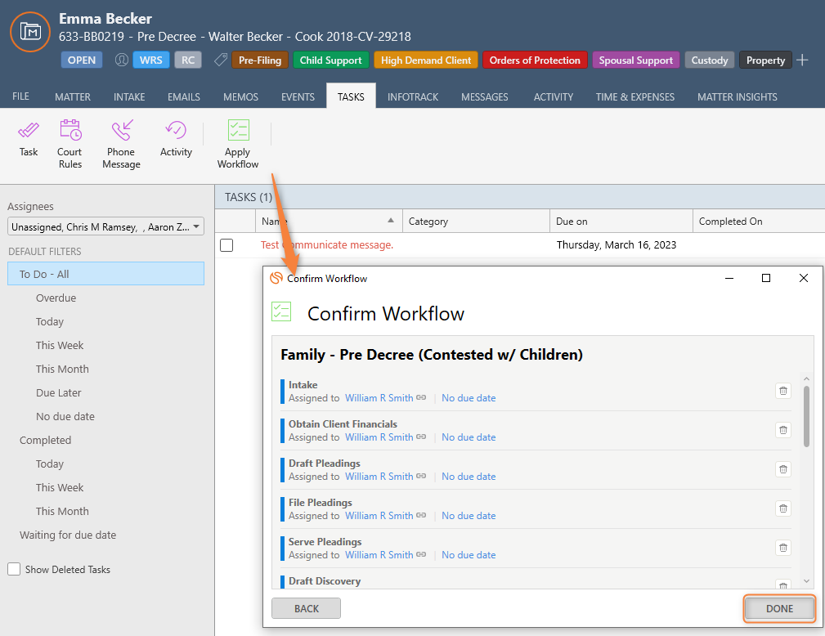
The tasks will now show on your main dashboard, and in the task section of the matter. Be sure to review the tasks when applied, and ensure they’re completed when done.

***If a task is not required or does not need to be completed, delete the task (Complete or Delete tasks). You can always edit this if made in error. ***

Conflict Checks

While first setting an appointment with a potential client, Jesse will collect all relevant information and contacts for the client and others persons/businesses involved in the matter. He will run a conflict check inquiry in Smokeball and save it to the potential client’s lead.

Each afternoon, Jesse will send an email to SLOconflictcheck@mttaxlaw.com with the list of persons noted above in the email. Everyone will review this email. If there is a potential conflict, they will review the conflict check in Smokeball and respond to the email only if there are potential conflicts.

When conducting a search in the Advanced Search tab, select Save Conflict Check.
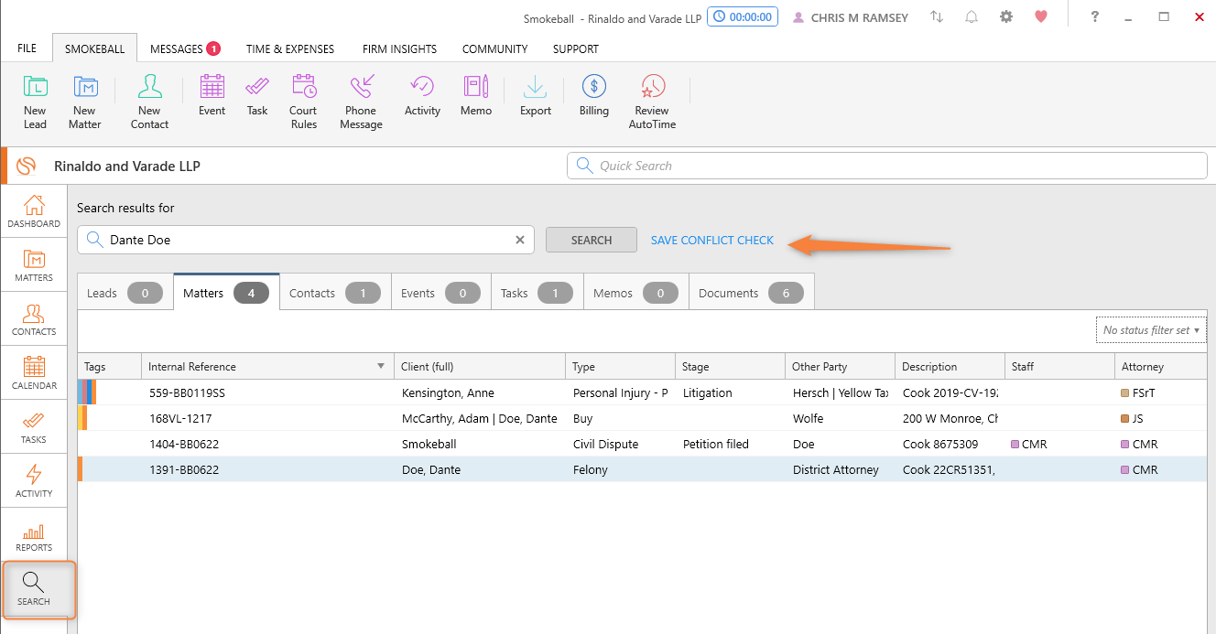
Upon selecting this option, you will be presented with a pop-up to assign the results to an existing matter or lead and record any notes you have regarding the results.
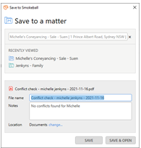
You can also rename the PDF file and choose a folder in the matter. When ready, save the PDF to the matter.
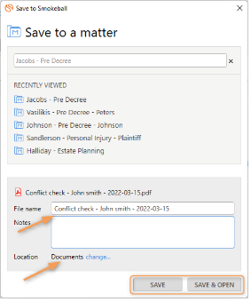
This will save a PDF copy of the conflict check results to the matter or lead containing all search results and any notes you took down at the time of assessment.
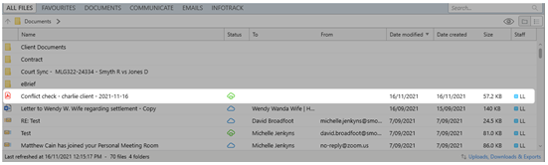
Search Results and Matter Permissions:
- A warning will be displayed when there are documents or memos restricted from view due to matter permissions set against the user conducting the search to ensure that the results provide a full picture of what may exist in Smokeball.
- This is intended to help the intended reader of the report understand that there may be important items missing and decide whether to explore further.
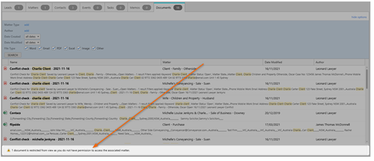
The Conflict Check PDF:
The resulting PDF will contain a list of all the search results seen in the Advanced Search interface.
The cover page will display:
- The name of the user that conducted the search
- The name of the matter the PDF was saved to
- A timestamp of when the search was conducted
- The notes added at the time of saving
- A hyperlinked summary list of totals
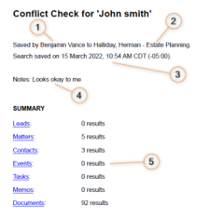
The remaining pages will contain the results of the search.
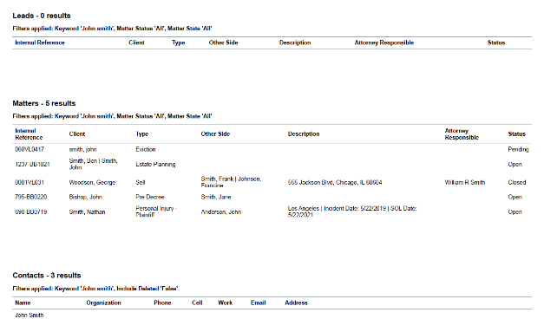

Payment Procedure
Methods we accept:
- Check
- Cash
- Credit Card (Amex, VISA, and MasterCard) over the phone or online
- Bank Transfer (ACH)
Check Procedure
***No cash or checks are to go home with anyone at anytime.***
All cash and check payments received must be deposited within 24 hours. If a payment is received after hours, please place payment in the safe deposit box and deposit first thing in the morning.
The check amount is more than what the client owes:
- Record the payment on Smokeball- Under that client name.
  - Place the money in the IOLTA account.
    - Pay the invoice- using funds from the retainer.
Occasions where the payment will need to be returned to the client. See Below:
- Duplicate payment
  - If you verified in Smokeball a payment has already been processed for the same amount you just received, you must call the client to let them know.
    - Give them two options:
      - “Would you like to place the duplicate payment in your IOLTA account for future use?
-or-
      - “Would you like me to return the payment?
        - The duplicate payment must be returned if the client a.) requests the payment to be sent back or b.) if you were unable to get ahold of the client.
- Settlement Payment
  - The Settlement payment was received in the client’s name.
    - You must send the settlement check to the client withing 24 hours.
      - Certified Return Receipt Requested
        - Place a note in the client file stating: Check identification {Name of Source, What type of check (Settlement or etc.), Check No.}, and the Certified Return Receipt Requested No.

Cash Procedure
- Cash Payment
  - All cash payments must have a completed Non- Customer Currency Transaction Report (CTR) Form
    - Non- Customer Currency Transaction Report (CTR) Form is located: Silverman- Finances- Deposits-CTR- Non-Customer Form
      - Code of Federal Regulations Part 1010.312 requires all CASH paying clients to file out a Non- Customer Currency Transaction Report (CTR Form) upon accepting and depositing cash payments in our IOLTA or business checking accounts.
Bank Transfer or ACH
- All (ACH) transactions need to be first approved by the Office Manager
  - Once approved:
    - Office Manager
      - Will give Silverman Law Office (ACH) information to the client.
        - Confirming ACH information
          - Helena Checking- Only
        - Specifying to the client
          - All ACH transactions must have the same name that is reflected in Smokeball.
        - Review Helena Checking account on a weekly basis for ACH payments.
          - Apply ACH payments on Smokeball under correct client name.

Create a Lead

Jesse will create the leads. Leads are created for all new matters. If hiring an existing client, we still want to follow the leads process to track these metrics in our PCLC.

- Smokeball Dashboard, at the top left there is a New Lead Icon, select this.
- Identify if it is a person, business, or trust
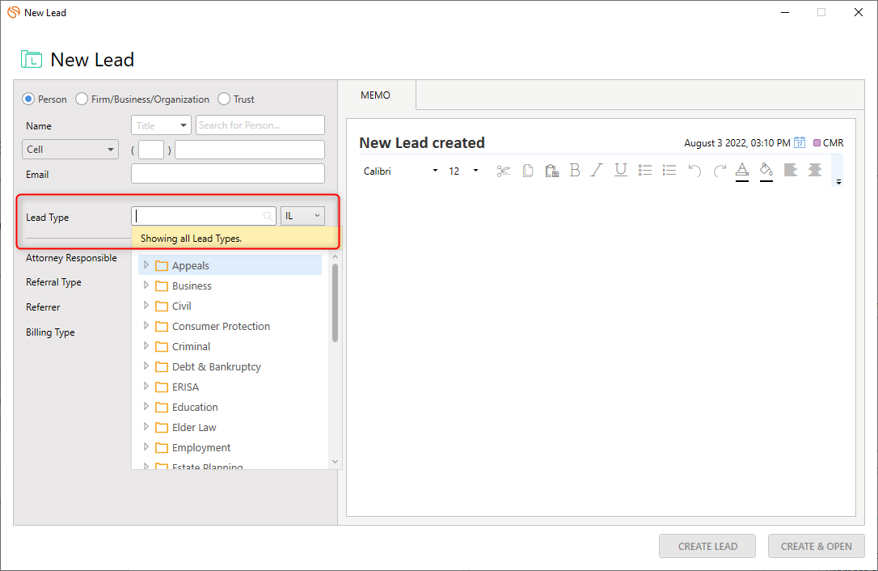
- Enter Basic Lead Information
  - The name will simultaneously search for existing contacts throughout Smokeball
  - Enter Name
  - Enter Phone Number
  - Enter Email
  - Enter contact notes
- Enter Lead Type
  - Current Lead Types
    - General (All litigation, liquor and gaming, professional licensing)
    - Probate
    - Business (Including Cannabis)
    - Estate Planning
    - Real Estate
    - Guardianship
    - Tax
- DO NOT enter intake form
- Enter referral info.
  - TYPE - Attorney, Accountant, Facebook, Web, Etc.
  - REFERRRER – Note who specifically by name
    - If it is a business, you will need to re-enter it after you open the lead file
- Enter name of client coordinator. Enter your name if meeting is not scheduled.
- DO NOT enter billing type
- DO NOT enter estimated fee
- Click the timestamp button and add notes
- Click Create & Open
- Click on Assign New Lead Tasks
New Lead – Web Lead
- Check Web Intake Leads widget for new leads
- Open each new lead
- Click on Assign New Lead Tasks
- Copy intake notes from documents section to memo section
- Under the info section, change referral type to website form inquiry
- Under the Lead Type section, pick the right lead type from the list (if not general)
- Add the following folders to the file section
  - Documents From Client
  - Engagement Agreement
  - Notes
New Lead – LegalMatch
- Check the new leads section
- If the lead is unqualified
  - Give it a one star rating and provide a reason so LegalMatch can filter out these types of cases in the future
  - Archive the lead
- If the lead is qualified
  - Reply using the templates or a custom reply
  - LegalMatch will follow up with a phone call to make sure they saw the reply
  - If you make contact with some, add them to Smokeball as a new lead as if it were an incoming call
New Lead Window
- If you did not make contact
  - Delete all of the tasks in the workflow
  - Leave lead on the “New Lead” stage
  - Change status to “Closed”
  - Under “lead closed reason” select “non responsive”
- If you made contact but it’s not qualified
  - Check off “Gather Initial Contact Information” task
  - Delete remaining tasks
  - Click “Info”
    - Change Status to Closed
    - Under “Lead Closed Reason” select “Not Fit For Business”
- If it’s qualified but meeting was not scheduled
  - Check off “Gather Initial Contact Information” task
  - Check off “Qualified” task
  - Delete remaining tasks
  - Select “qualified lead” under stages
  - Click “Info”
    - Change Status to Closed
    - Under “Lead Closed Reason” select reason
- If meeting is scheduled
  - Set Internal Reference
    - Click on “info”
    - Click on “Internal Reference”
    - Use this naming formula: “3-1-24 Consult”
  - Set meeting rate
    - Click on “info”
    - Click on “billing”
    - Click on “Billing Type” and select “Time Based”
    - Under Hourly Rate, select “Override default rate per staff member”
    - Select client coordinator, add rate, and click “add”
  - Add address
    - Click on “Prospect”
    - Select “Address”
      - Always add address to physical address field, not mailing address field
  - Run conflict check
    - Gather names of all involved parties
    - If it is a contested matter, be sure to get names of opposing parties
    - Search Smokeball for all names and save conflict check to the lead file
    - If someone’s relationship to the firm is unclear in Smokeball, you may also need to check Practice Panther
    - If there are still questions about any names, send an email to sloconflictcheck@mttaxlaw.com right away
    - At the end of the day, add the names of all involved parties to sloconflictcheck@mttaxlaw.com
  - Booking the appointment
    - Add event to client coordinator’s calendar
    - Use this formula for subject line: “Jesse – Business Consult – John Smith – Paid”
    - Be sure to add Zoom link and info to body of calendar invite
  - Take Payment
    - Open Smokeball Browser (app.smokeball.com)
    - Search for client name
    - Select the correct lead
    - Select Transactions
    - Select Credit Card Deposit or Credit Card Deposit Request
  - Send confirmation email
    - Select the email icon at the top
    - Select the appropriate template signatures
    - Make necessary edits
    - Send
  - Check off the following tasks
    - Gather initial contact information
    - Qualified
    - Calendar meeting with client coordinator
    - Collect payment or note that client owes
    - Send confirmation email
  - Move lead to “Consultation Scheduled” stage
Canceling a Meeting
- Cancel appointment in Outlook calendar
- Close Lead in Smokeball
  - Delete remaining tasks
  - Click on the + symbol and add the “canceled” tag
  - Click on “Info” and change the status to Closed
  - Add the Lead Closed Reason
- Create a refund request
  - From the Lead in Smokeball, click on “Task”
  - Name: Use the following formula – “Refund $500 to John Doe”
  - Assigned to: Shalee Minton
  - Due: Do NOT select a due date
  - Details: Note that the meeting was canceled and the prospect needs a refund
  - Save

Introduction Email – Becki

Following Retainer of Fee payment with the Client Coordinator, an introduction email will be sent to the client:

Hi *Client Name*, it was great speaking with you! As mentioned, the next step in our process is to get an Engagement Agreement prepared, drafted, and signed so that we may begin working on your matter.

I would like to introduce you to Becki VanDyke, our Administrative Assistant. Becki will contact you regarding your Engagement Agreement and ensure you know how to communicate with your legal team, send and receive documents, so our team has the information needed to prepare for a productive onboarding session with you.

To learn more about Becki, you can visit https://mttaxlaw.com/about-us/becki-vandyke/.

Thank you for trusting Silverman Law Office.

Legal Team Introduction Email

Click on email this will bring up (and save) any and all emails and should only be sent from Smokeball so we can ALWAYS save every interaction with our clients and for the email drip.

Please copy and paste the appropriate template:
Appointment Confirmation email – Meet the Attorney Helena

Hi *Client name*, it was a pleasure to speak with you! Below are some links to videos on our YouTube channel so you can get a better feel for our law office and meet attorney *Attorney name* virtually. I highly recommend subscribing to our YouTube channel as we put out a lot of great information for folks.

(If EP),( Attached is an estate planning questionnaire for (single or couple). Please fill this out and upload them with Smokeball Communicate or email them to me ahead of time so we can put them in our system and the attorney can then electronically access them for your Onboarding. This gives everyone better feel for what you are trying to achieve with your estate plan.) (MAKE SURE YOU ATTACH EP QUESTIONNAIRE)

Copy & paste the appropriate attorneys into the email:

Joel Silverman
https://youtu.be/u1uV7cW0gOg

Mark Jette
https://bit.ly/34cbvMB

Chris Walker
https://bit.ly/2K7gbwD

Tony Dalton
https://mttaxlaw.com/about-us/tony-dalton/

Appointment Confirmation email – Meet the Attorney Bozeman

Hi *Client name*, it was a pleasure to speak with you! Below are some links to videos on our YouTube channel so you can get a better feel for our law office and meet attorney *Attorney name* virtually. I highly recommend subscribing to our YouTube channel as we put out a lot of great information for folks.

If you have documents you have for your legal team, please upload them to Smokeball Communicate or email them to me ahead of time so we can put them in our system and the attorney can then electronically access them for your Onboarding.

We look forward to meeting with you, our office is located at 504 W. Main Street, Bozeman MT.

Jill Russell
https://mttaxlaw.com/about-us/jill-russell/
Grant Dickson
https://mttaxlaw.com/grant-dickson/
Kasey Kimball
https://mttaxlaw.com/about-us/kasey-kimball/

Copy & paste a link to whichever scope pertains to the client’s consultation:
10 Keys to Estate Planning Video
https://www.youtube.com/watch?v=LeOwtmZfcHw
Estate Planning FAQs Video
https://www.youtube.com/watch?v=5a0ztbp1w8Y
Real Estate FAQs Video
https://www.youtube.com/watch?v=Syl4CdfoVck
Professional Licensing Law
https://youtu.be/b-Nyn4_ZHyY
Guardianship & Conservatorship
https://www.youtube.com/watch?v=2twD49d5Cvo
Liquor and Gaming FAQ’s
https://www.youtube.com/watch?v=bJcJ7KiBygo
Marijuana
https://youtu.be/XN0QXcMrD8Y
Employment & Labor Law
https://t.ly/employmentandlabor
Tax FAQ’s
https://www.youtube.com/watch?v=nDsqxLydhAc&t=12s
Business FAQ
https://www.youtube.com/watch?v=idabZylzaNg
Probate
https://www.youtube.com/watch?v=Nb-H7K0NDLA

No-Show & Rescheduling Protocol

What to do if a potential client doesn’t show up:
If a potential client doesn’t show up for an appointment Jesse will call to see what happened, why they didn’t show, and reschedule. When you talk with the potential client on the phone, they will then transfer the call to Jesse to reschedule the appointment. Jesse will make the potential client accountable for showing up for their new appointment. Accountability statement:

“We value your time and ours, do you promise to give us a call if you can’t make the appointment?”

What to do if you try to rebook the no-show and you can’t reach them:
We must make four attempts to contact the no show.
- First Becki will try calling and leaving a polite voicemail asking the potential client if they need to reschedule.
- Becki will then try and call back later in the day or the following morning to reschedule.
- If Becki still hasn’t heard back later in the day from the potential client Becki will send them an email. Use template below.

Reschedule E-mail Template:

Dear [NAME],
We were looking forward to meeting with you on [date] at [time]. We value your time and ours please let us know when would work best to reschedule. We look forward to reconvening with you.
To reschedule please call us at (406) 449-4829. We look forward to hearing from you soon!
Sincerely,
[NAME]
- The final attempt is to mail a letter. You can print off the email template and send it out the same day you send the email. That way the letter will be received a few days later.
If we do not hear back from the no-show after four attempts, Becki will leave a note in Practice Panther that all four attempts have been made. We will make sure their information is in Practice Panther, so they are in our drip funnel for marketing. If they call us back later to reschedule Becki will make them accountable for showing up.
Becki handles all these steps if it is a teleconference appointment.

If a client calls to reschedule on their own, email the attorney and cc Becki so they aren’t concerned that a client is a no-show.

Appointment Reminder Phone Calls

Appointment Reminder Call Duties
Reminders must be made the day before the potential client comes in. Friday you will call for Monday’s consults.
- Each business day, the receptionist in Helena will conduct the following reminders for upcoming Helena consults.
- Each business day the receptionist in Bozeman will conduct the following reminders for upcoming Bozeman consults.
- If one of the receptionists is unavailable, then the receptionist in the other office will conduct these reminders for both offices that day.

In Person Meeting
This is (name) from Silverman Law Office. We have an appointment set for you tomorrow with Jesse. We look forward to seeing you on (date) at (Time) (Office Location). Please give us a call at 406-449-4829 (or 406-582-8822) if you are unable to make this appointment.

Remote Meeting
This is (name) from Silverman Law Office. We have an appointment set for you tomorrow with Jesse. We look forward to seeing you over Zoom or Phone on (date) (time). Just as a reminder, the remote Client Coordinator Meeting fee must be paid before the day of the consultation. Failure to pay fees for the remote consult will result in meeting cancelation. Thank you for your understanding, we look forward to meeting with you.

Documenting Reminder Calls
Once reminder calls have been completed note in the calendar event that the person has been called and if you spoke with them or left a voicemail (put CF in front of the attorney or attorneys’ names if they confirmed or VM if you didn’t get them, call again in the morning if they haven’t paid and it says link sent). You will also add PAID or OWES to the calendar event.
- If there is relevant client information that is discovered during the follow-up, please relay the info to the attorney and add it to the notes section.

Reminders must be made the day before the potential client comes in.

If you don’t get ahold of them and they do not end up in the consult, refer to No Show Protocol

Consult Complete Email Format

To be included in the Consult Complete Email

Email will be addressed to consultcomplete@mttaxlaw.com and the team (attorneys and paralegals) who will be working on the matter.

- ATTN:
- Summary of consult:
- Lead Source:
- Retainer Amounts:
- EA Draft -
  - Client Details:
  - Matter:
  - Hourly Rate:
- Onboarding Date:

- Notes:

Engagement Agreement Follow-Up Procedure

- Check the PENDING HIRE STAGE to follow up with clients who have not signed the Engagement Agreement and or paid the retainer/flat fee.

- There should be three dates for following up, per client. The day after (Follow up – A), three business days after (Follow up - B), and then the seventh business day (Follow up – C) to call.
  - Follow up A, B, & C are set as Tasks in Practice Panther
    - Be sure to put notes in Recent Activity of the Task then press complete, if you were unable to reach the potential client, add Follow up – B, which is three business days later.
  - Make sure the daily reminder has been selected in Abode.

- All follow-up communication should be generated from the Lead, so the emails are saved.
  - Key Points for Phone Call
    - Has the client received the Engagement Agreement?
    - Is the client’s email address correct?
    - Is the client’s address correct?
    - Make a note of recent activity regarding the call.

- If the client does not answer the phone or respond to emails, then mail the Engagement Agreement to the client.

- If the client does not mail or email back a signed engagement agreement within 7-10 days of the mailed engagement agreement, then we will put work on hold until the client sends a signed engagement agreement.

* Becki will send the Bozeman and Helena attorneys an updated list every week via email of clients who have either disengaged or have not sent us a signed engagement agreement, and/or have not paid.

Convert a Lead to a Matter

Select the Convert to Matter button above Lead Details to start the process.
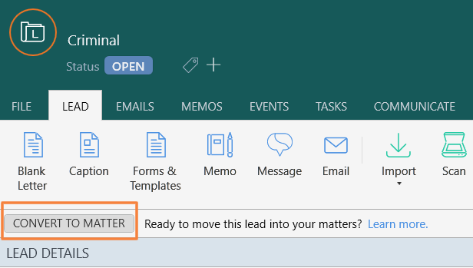
- Go to “Convert to Matter”
- Select the specific “Matter Type”
- Then verify the conversion
Converting a lead to a matter is not a reversible process. You'll be presented with a confirmation box to check if you still wish to proceed.
- If the Lead Type and Matter Type are 100% compatible, the user will see the following prompt:
- If the Lead Type contains contacts or layouts that do not exist in the Matter Type the Lead is changing to, you will see a warning prompt. Please note that leads currently only contain contacts.
  - Any incompatible data will be removed when converted.
  - Make a note of the data before conversion for placing in the converted matter. Memos or contact cards can hold data in the new matter.
- Once converted, the heading color changes from dark green to dark blue and the icon changes from (L) to (M).
Update the Internal Reference Section with the appropriate Matter Name (Change from “Consult”)
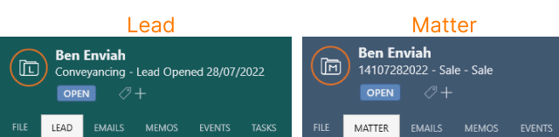

Onboarding Outline

1.Introductions

- Attorney
- Guests
- I’m Attorney Joel Silverman.
- You are John and Jane Doe, correct?

2. Brief Background

- Practice Area

- Experience

- Personal Story

- I practice estate planning, tax law, business law, and other types of contractual law.
- I’ve been an attorney since 2003 and went to school for another year to get my LL.M in taxation, which is an advanced degree for attorneys.
- I spent nearly six years as an attorney for the Montana Department of Revenue, where I worked on legislation, liquor and gaming matters, and litigating various federal and state tax law issues.

3. Introduce Legal Team

- Co-counsel

- Paralegals

- This is Associate Attorney Cody Townsend, who also holds an LL.M. in taxation and will be working with you throughout the process.
- You may also hear from Heather McCracken, our paralegal who assists our estate planning clients.
4. The Firm

- Origins of firm

- Experience

- Applicable practice areas

- Joel Silverman opened Silverman Law Office in 2012 because he recognized that people need lawyers who focus on the client’s goals and needs, not just their legal issues. We now have offices in Helena, Bozeman, and Big Timber.
- Our firm has nine attorneys across the state, with more than 100 years of collective experience among them.
- Our attorneys have experience in a variety of practice areas including tax law, real estate law, and business law, and they are all available to you as a client.

5. Review Notes

- Hell

- Heaven
- I’m sorry to see that you are going through this audit with the IRS. What is your main concern throughout this process?
- In an ideal world, what would be the best outcome for you?
6. Legal Work

- Estate Planning Flat Fee (if applicable)

- Company Format Flat Fee (if applicable)

- Based on what you’ve shared with me, I think it would benefit you to convert the retainer to a flat fee. This will cap the total cost of your estate planning at $3,000, so you won’t pay anything beyond what you’ve already paid. This allows us to spend as much time as needed to ensure your plan is exactly the way you want it, without you having to spend any additional money. Would you like to proceed with that?
- Based on what you’ve shared with me, I think it would benefit you to convert the retainer to a flat fee. This will cap the total cost of this project at (INSERT AMOUNT HERE*), so you won’t pay anything beyond what you’ve already paid. This allows us to dedicate as much time as needed to ensure everything is set up exactly the way you want it, without you having to spend any additional money. Would you like to proceed with that?

7. Conclusion

- Manage client expectations

- Define Next Steps

- Express gratitude

- I have a couple of pressing projects this week but will get to work on this as soon as possible.
- Our paralegal will send your appeal to you as soon as it is ready, and we will file it with the IRS after you sign off on it.
- Thank you for trusting us to help you through this process.

Scorecard:
Introduction (total of 5 points)
- Confident in tone and initial contact: up to 2 points
- Self: 1 point
- Team: 1point
- Firm: 1 point
Total ______

Heaven & Hell (total of 3 points)
- Heaven: 1 point
- Hell: 1 point
- Summarize Heaven: 1 point
Total ______

Get to Work (Total of 9 points)
- Clarify and collect all necessary information: 3 points
- Clearly articulate strategy and confidence in outcome: 3 points
- Discuss changes to EA regarding Flat Fee: 3 points

Total ______

Conclusion (total of 3 points)
- Manage Client Expectations: 1 point
- Mentions prompt response to their needs: 1 point
- Thank the clients and reassure: 1 point

Total ______

GRAND TOTAL: ____/20
(17 is a passing score)

Qualifying Call /Return Client Outline

- Introduction (2 minutes)

- Attorney
- Guests
- Practice Area / Self
- Firm

- I’m Attorney Joel Silverman
- You are John, and Jane Doe, correct?
- I am a (practice area) Atty
- Our firm is unique as our team provides over 100 years of comprehensive legal experience and knowledge. We work collectively to provide you with the utmost support on your case.

2. Review Notes (3 minutes)

- Let’s get going
- Summarize the situation

- Heaven

- Hell
- Listen
- I’m sorry to see that you are going through this audit with the IRS. What is your main concern throughout this process?
- In an ideal world, what would be the best outcome for you?
- What outcome are you trying to avoid?
3. Get to Work (8 minutes)

- Strategy

- Additional Information

- Consult
- Now that we are on the same page, I want to come up with a strategy to ensure we get the best possible outcome.
- Are there any additional contacts or information available to review?
- Verify our side
- Verify opposing side
- Outline path/plan to achieve goals.

4. Conclusion (2 minutes)

- Can Help

- Can’t Help

- So, it looks like we can represent you. The retainer needed to start will be ____. Once it’s paid, I’m going to get with the team so we can get started. (manage expectations)
- After reviewing the details of your matter, I do not think we can represent you. You could try ___. (if options are available)

- Consult Complete

- Send Consult Complete Email.

Onboarding Script

ESTABLISH RELATIONSHIP
15-Minutes (Establish confidence & competence through experience and expertise in you and the firm)
- Introduction
  - Hi, nice to meet everyone. Confirm you are _____________.
  - My name is ________, an attorney with Silverman Law Office. I want to start by letting you know who you are talking to and working with.
  - SELF: I am a (practice area) specialist here at SLO, one of the most well-respected law firms in Montana! For some background on myself… I am dedicated to serving upstanding Montanans like yourself and have worked with hundreds of clients in the area of practice.
  - LEGAL TEAM: Also, the team that will work with us is ________. He/she also has extensive experience on these matters. They may reach out to you directly by phone or email, so I want to make sure you know who they are as well.
  - FIRM: Lastly, something that sets us apart from many other firms, is we have access to every other member of our team, to dip into their experience and knowledge to ensure you’re getting the utmost level of support on your case. Example, tax matters we can talk to Joel, we have litigation attorneys, professional licensing specialists, real estate specialists, and more.

- Build Rapport
  - Find something to connect with the client (sports, attire, season, etc. Something to say, “I like that too” to establish commonality)
  - Let’s get to it. I had a chance to review the summary of your case and the documents you submitted (if applicable). However, I want to hear from you about what is going on.
  - Provide a feedback summary (***DO NOT CONSULT YET***).
    - So, to make sure I understand, what you don’t want to happen is ________.
    - And what you would like to achieve from this is ________.
  - THANK YOU. It is very important to me that I have a deep understanding of your situation and expectations, to make sure we are on the same page.

LEGAL WORK
15-30 Minutes of getting to now the intricacies of the matter, and begin consulting and coming up with a came plan to achieve their desired outcome.
- Get to Work
  - Okay, now that we are completely on the same page, I want to come up with a strategy to ensure we are getting you the best possible outcome.
  - First, let me clarify meeting participants.
  - Are there additional contacts and information needed?
    - Verify our side:
    - Verify opposing side:
  - Consult with the client about path/plans to achieve their goals and avoid their concerns.
  - Note to the client any other matters (estate plan, trademark, contract review, etc.) we can assist with
  - Discuss rates, fees, and retainers.

- Conclusion
  - Well, ____________, this was a great first meeting. I’m going to get with the team immediately following this so we can get started on your project as soon as possible (manage client expectations).
  - I want to thank you for trusting us to assist you in this. We always do our best to get the best desirable results for our clients.

Scorecard:
Introduction (total of 5 points)
- Confident in tone and initial contact: up to 2 points
- Self: 1 point
- Team: 1point
- Firm: 1 point
Total ______

Build Rapport (total of 5 points)
- Build a connection: 2 points
- Ask for summary: 1 point
- Provide Feedback: 2 points

Total ______

Get to Work (Total of 10 points)
- Clarifying and collecting all necessary information: 3 points
- Clearly articulating strategy and confidence in outcome: 3 points
- Discuss other practice areas that we can offer: 1 points
- Discuss rates, fees, retainers: 3 point

Total ______

Conclusion (total of 2 points)
- Mentions prompt response to their work: 1 point
- Thank the clients and reassure: 1 point

Total ______

GRAND TOTAL: ____/22
(20 is a passing score)

Qualifying Call and Returning Client Script

15-Minute Call
- Introduction (5 Minutes)
  - Hi, this is _________, thanks for calling. Is this _____________? Great, anyone else on the phone with you?
  - Okay, this call should only take about 15 minutes, so let’s get to it. (Can skip C & D if a returning client)
  - SELF: My name is ________, an attorney with Silverman Law Office. I am a (practice area) specialist here at SLO.
  - FIRM: Something unique to our firms is we have access to every other member of our team, to dip into their experience and knowledge to ensure you’re getting the utmost level of support on your case.
  - Let’s get going. Please give me a quick summary of what is going on AND what you hope to accomplish.
  - Provide a feedback summary.
    - So, to make sure I understand, what you don’t want to happen is ________.
    - And what you would like to achieve from this is ________.
- Get to Work (8 Minutes)
  - Okay, now that we are completely on the same page, I want to come up with a strategy to ensure we are getting you the best possible outcome.
  - Are there additional contacts and information needed?
    - Verify our side:
    - Verify opposing side:
  - Consult with the client about path/plans to achieve their goals and/or avoid their concerns.
- Conclusion (2 Minutes)
  - (Can Help) So, it looks like we can represent you for your matter. The retainer needed to start will be ___________. Once, that is paid, I’m going to get with the team immediately following this so we can get started on your project as soon as possible (manage client expectations).
    - Do you want me to help you with this? Direct to Jesse for retainer, if so.
  - (Can’t Help) After reviewing the details of your matter, I do not think we can represent you and in this. You could try ______ (if other options are available).
- Send Consult Complete Email

